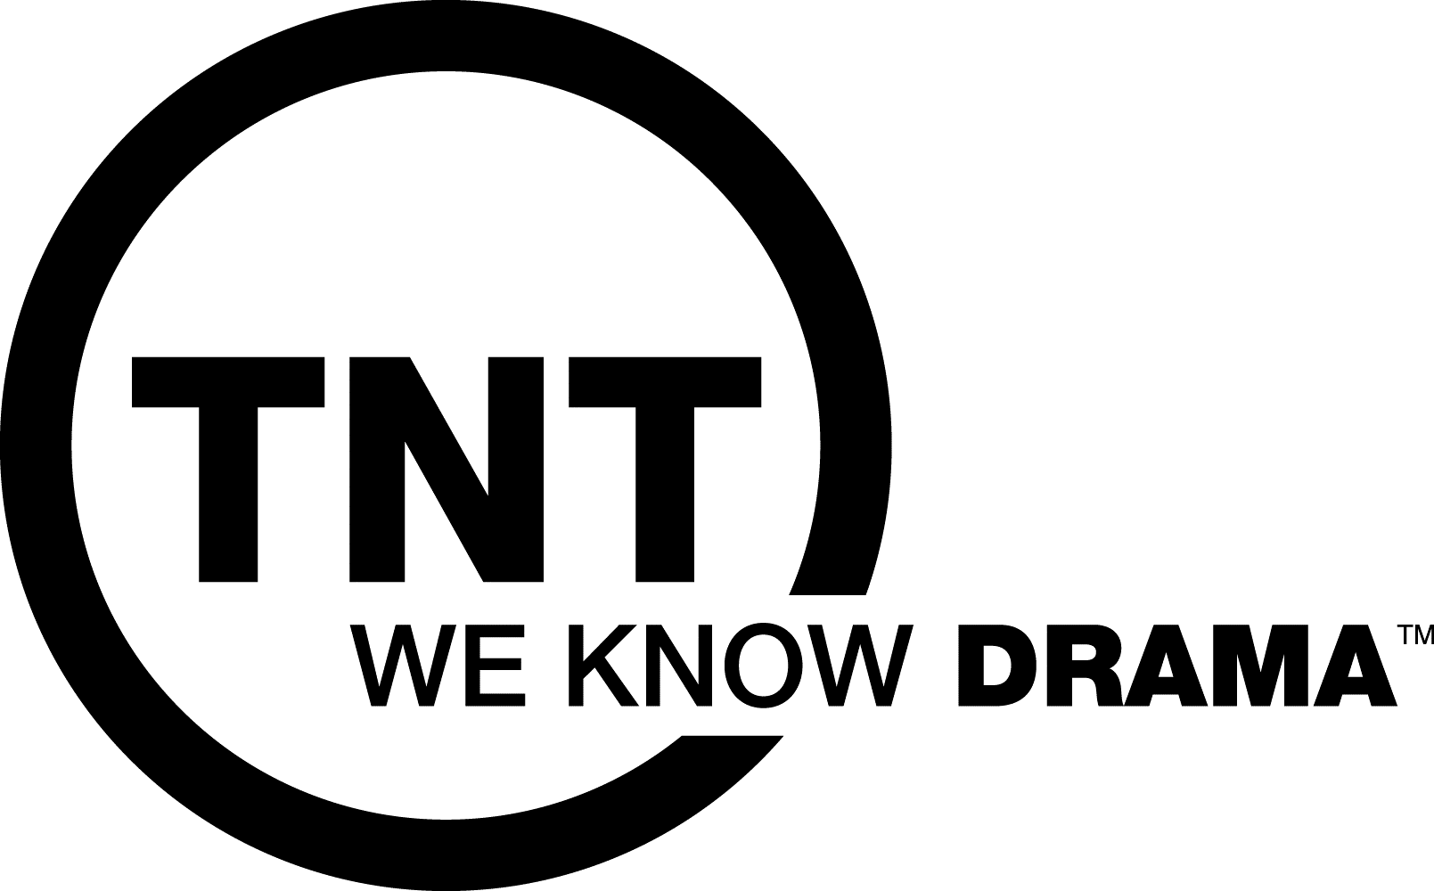

The Mentalist - HOW DO I KNOW?

Patrick Jane looks into the camera, seducing and mesmerizing us.

JANE: How do I know that you're going to watch The Mentalist on TNT? It's simple. There are any number of tell-tale giveaways. Little things you don't even notice you're doing. But, I do. And I know what they mean.

{Cut to a montage of close-up broll shots of the following tics Jane describes. It's not entirely sexual but close enough.}

JANE: Your eyes widen. You bite your lower lip. Your fingers slowly uncurl from your fist. You breathe in sharply. Your mouth opens just a bit.

{Now back to Jane.}

JANE: Of course, you're going to watch. Why wouldn't you?

VO: THE MENTALIST
MONDAYS (WEEKNIGHTS) ON TNT.
WE KNOW DRAMA.

